**“OKHAI”**

**Strategic Analysis and Advertising Campaign Management for Okhai's New Sustainable Fashion Collection**

Date of Submission – 16th Aug 2024

## **Introduction**

Brand Vision: Empowering women and children with sustainable occasion wear.

## **Company Overview and Mission**

Okhai is an online startup that offers a sustainable line of occasion wear for women and children. It resides at the intersection of ecological and ethical fashion, which caters to people who are environmentally conscious and look for the story behind their product in terms of transparency, quality, and cultural heritage. Okhai sees an opportunity to make a positive difference in people and the planet with high-quality, handmade apparel that reflects the rich cultural heritage of India. While the fast-fashion players dominate the fashion market, Okhai stands with its advocacy for slow fashion, focusing on sustainability and ethics. Carving out a niche for itself in the space of occasion wear puts Okhai at differentiating itself as a socially responsible alternative to mainstream fashion. Hence, it is able to build a base of customers who remain loyal because of its values of sustainability and ethical consumption.

## **Objective**

The campaign is undertaken to promote Okhai's new collection of sustainable occasion wear for women and children through suitable advertising channels. This campaign is to raise more brand awareness, increase online traffic, and increase sales but it is subject to the budget constraints suggested by the board of directors. With effective digital marketing, social media, and influencer partnerships, the campaign will reach out to the environmentally sensitive consumer, communicate the brand philosophy on sustainability, and make Okhai the top-of-mind preference for those seeking stylish yet ethical fashion.

## **Business Process/Task Definition**

**Business Process**

The focus is on Okhai's Marketing Campaign Management, with a special focus on the promotional work of its new collection.

**Key Performance Indicators (KPIs):**

1. **Budget**: Advertisement spending should not exceed INR 100,000.
2. **Number of Online Ads**: A minimum of 15 advertisements for each of the selected media should be placed.
3. **Selection Criteria of Number of Ads for Various Media** : The number of online ads to be placed should at least be the same as of that of the print ads.

**Scenario Definition**

Okhai has a budget of INR 100,000 to spend on advertising using two modes of advertisement (online and print). Each online ad costs ₹ 300 and reaches an estimated 5000 people, while each print ad costs ₹ 800 and reaches an estimated 10,000 people. The startup manager wants to maximize reach, with a stipulation that at least 15 ads of each type be used. Also, the number of online ads must be at least as great as the number of print ads.

### **Problem Statement**

Find the optimal mix of ads to maximize reach and determine how many of each should be produced.

### **Solution**

Linear programming can give the number of each type of ad that should be produced to achieve maximum reach, subject to four resource constraints.

### **What-If Analysis Techniques:**

1. **Scenario Manager**: This was used to find the best case and worst-case scenarios of online and print ads that could be allowed within a given constraint of a fixed budget. It allows one to test different scenarios by changing, for example, the numbers of ads to see their effects on total reach and how much of the budget is used.
2. **Data Table:** This is used to determine which mix of ads remains in budget and which go over. The analysis places both scenarios into context, whereby it clearly shows what the advertising strategies stay within the budget and which do not.

The table expresses, by view, the breakup of whether or not ad campaigns stayed within budget. The derived analysis is that, out of a total of 50 ad campaigns, 29 remained within budget and 21 overshot the budget. This suggests that most campaigns don't breach the set budget; however, a significant number of them do go on to overshoot it. This insight calls for a closer look at campaigns above budget to find a pattern or cause that mitigation may be built into future strategies.

1. **How to use Solver to solve the problem:**

* Build cells for variable data.
* Build an objective function to maximize reach.
* Create a constraint table based on provided KPIs.
* Input data in the solver.
* Run the Solver to view recommendations and generate Reports.

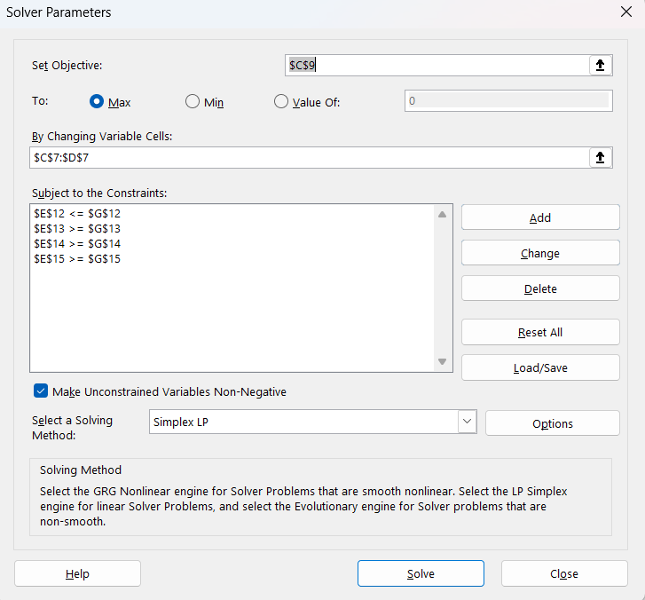

## **Data Visualization**

Different Charts are used to visualize the data and results properly.

1. **Total cost vs. customer reach**

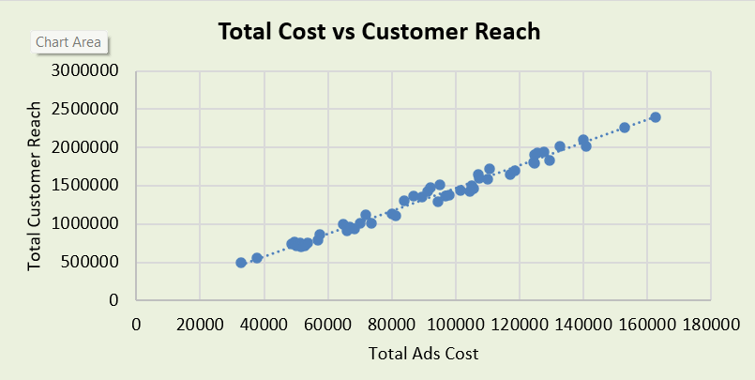

This scatter plot highlights the strong positive correlation between the total advertisement spending and total customer reach. That is, as more is spent on ads, the number of customers covered goes up. The trend line is that the incremental increase in spend budgets leads to incremental increase in customer reach, which holds that the marketing strategy is efficient in converting this investment into customer engagement.

1. **Online Ads vs Print Ads: Total Reach Over Time**

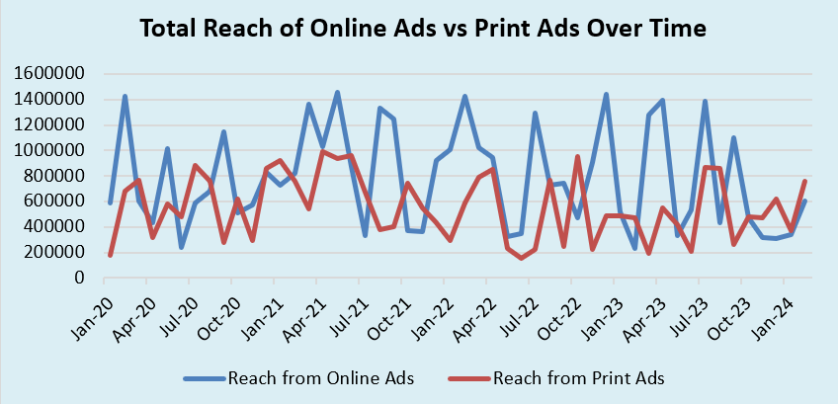

The line chart plots the time series for the total reach of online ads versus print ads from January 2020 to January 2024. Needless to say, online ads always have a higher reach than print ads. There are minor periods where print ads reflected slight increases in reach, but generally, online ads dominated regarding effectiveness. This insight thus supports the recommendation to focus more on online advertisements to maximize the reach of the audience.

1. **Budget Surplus/Deficit**

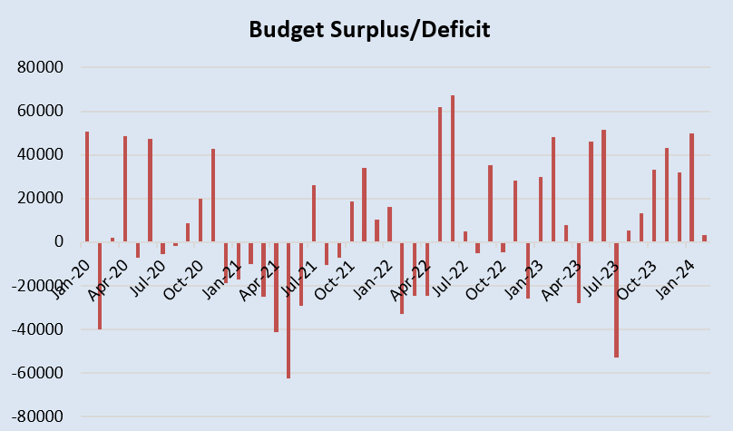

The bar chart indicates the budget surplus or deficit over time. There are multiple periods where the budget overspent beyond the limits since they indicate negative values, particularly the periods around April 2021, July 2022, and December 2023. Other times, it has a budget surplus, which is positive, thus not all the resources allocated were spent. This trend in the graphs shows that sometimes the budget is managed loosely, and therefore there is a need for tightening the hold on budgets or reviewing the strategy in the deficit periods.

1. **Online Ads vs Print Ads Over Time**

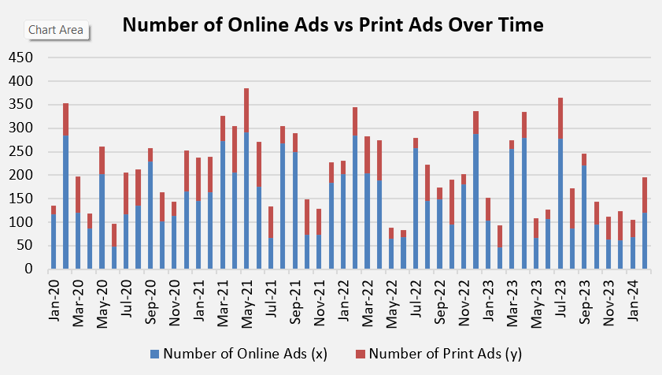

The bar chart expresses a comparison between online ads and print ads over time. The number of online ads, from the strategy, is always higher than the print ads through the timeline. Again, this goes in line with a strategy to maximize reach via digital channels. The constant higher number of online ads supports the trend in the total reach chart, thereby further validating this strategy.

## **Database Recommendation**

Based on the provided dataset, SQL is recommended for managing the data.

**Query Examples**

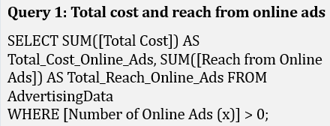

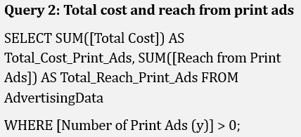

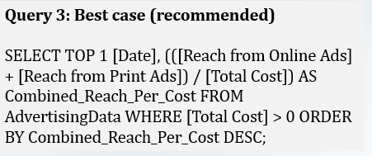

## **Recommendation**

On the basis of 'what-if' analysis and solver recommendations, the best advertisement strategy is to run 293 online advertisements and 15 print ads. This will maximize the reach subject to the budget constraint of INR 100,000. From the scenario manager analysis, this strategy presents the best case in terms of reach, efficiently using the budget subject to the stipulation that the number of online advertisements will be greater than or equal to the number of print advertisements.

The data table strengthens this approach by demonstrating that this combination of ads will indeed fit within the budget yet achieve maximum reach. It also gives some indication of other combinations that will stay within budget—that is, some other viable combinations—should flexibility be required during the campaign.

## **Conclusion**

The what-if analysis determined that there is a need to run **293 online ads** and **15 print ads** based on various what-if scenarios and under different budget constraints. It could be understood that this helped Okhai to reach its promotion goals in a much more effective way by ensuring adequate coverage of digital channels, which have better targeting and more reach than print ads. The scenario manager and data table tools will help in the in-depth analysis of strategies that may formulate the business decision on which advertising mix to use, basing on effectiveness and cost efficiency. If Okhai follows this recommendation, it will have a great opportunity to enhance brand awareness and, most importantly, increase sales of its new line of sustainable fashion.